# ASSIGNMENT (1-09-2025)

Submitted by: Srividya

Roll number: 23KQ5A0206

1. To check the Perfect Square number.

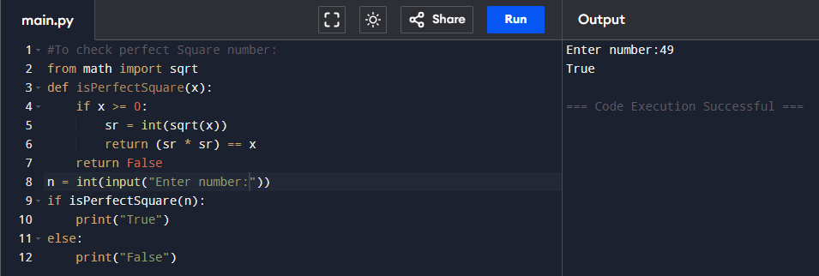

1. To check Automorphic number.

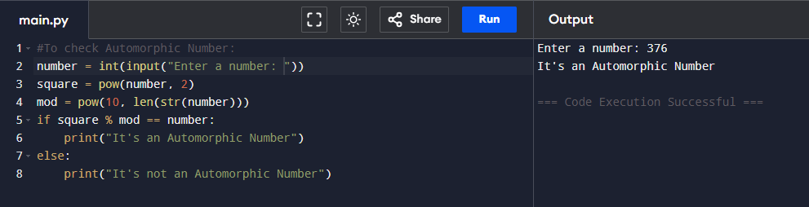

1. 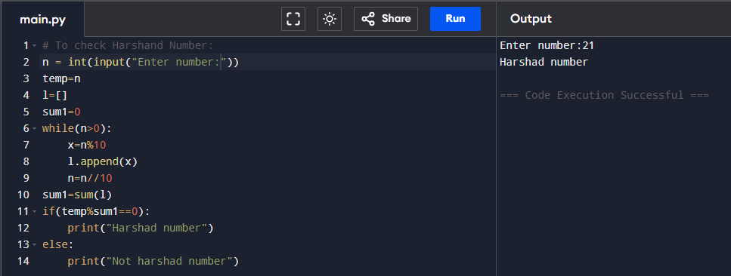To check Harshand Number.